**Technical Details of BQPI Simulation**

Table of contents

1. Introduction 2

2. The Physic and Math behind QPI and Bogoliubov QPI 2

2.1 The T-matrix Method 2

2.1.1 QPI Simulation 2

2.1.2 BQPI Simulation 5

2.2 The Joint Density of States (JDOS) Method 7

3.The Implementation of BQPI Simulation in MATLAB 8

3.1 The T-matrix Method 8

3.1.1 One-band model (e.g., BSCCO) 8

3.1.2 Two-band model (e.g., Sr2RuO4) 14

3.2 JDOS Method 22

3.2.1 One-band model (e.g., BSCCO) 22

3.2.2 Two-band model (e.g., Sr2RuO4) 23

4.Step-by-Step Guide of Software 25

5.Reference 26

# 1. Introduction

This MATLAB-based application is meant for consistent, rigorous, yet versatile simulations of quasiparticle interference (QPI) patterns using T-matrix and JDOS methods for materials assuming one- or two-band models.

# 2. The Physic and Math behind QPI and Bogoliubov QPI

The QPI pattern, which originates from elastic scattering from local defects, can be captured by STM spectroscopic imaging. The QPI pattern at certain energy reveals the *k*-space structure of the quantum states living at that energy. For a non-superconducting material, by acquiring QPI patterns across a certain energy range, one can retrieve the normal state dispersion $ϵ(k)$ of the quasiparticles (single particles). For a superconducting material, at energies far away from the superconductivity gap, normal state dispersion $ϵ\left(k\right)$ is similarly retrieved. Near the chemical potential, the canonical excitations of the superconducting ground state become Bogoliubov quasiparticles, allowing one to probe the momentum space structure of $Δ(k)$ by examining Bogoliubov QPI (BQPI) patterns.

A general ***k***-space binding Hamiltonian can be written as

$$\begin{aligned}H_{0}\left(k\right)= \sum_{α,β,k}{ϵ_{α,β,k}c_{αk}^{†}c_{βk}}\#\left(1\right)\end{aligned}$$

where $α, β$ denote orbitals/bands. The retarded single electron Green's function of the unperturbed system is defined as

$$\begin{aligned}G_{0}\left(k,E\right)={\left(E+iδ-H_{0}\left(k\right)\right)}^{-1}\#\left(2\right)\end{aligned}$$

where $δ$ represents an energy smearing due to finite experimental energy resolution. With $δ$ being finite, theoretically infinitely sharp and narrow peaks would have finite width. In practice, $δ$ is taken to be ~the energy resolution of STM measurements ($\sim 3.5$ $k_{B}T$).

## 2.1 The T-matrix Method

### 2.1.1 QPI Simulation

Including multiple elastic scattering processes linking two momentum eigenstates $k$ and $k^{'}$ of a normal material (i.e., non-superconducting),the Green's function of the system becomes

$$G\left(k,k^{'},E\right)=G_{0}\left(k,E\right)+G_{0}\left(k,E\right)U_{k,k^{'}}G_{0}\left(k^{'},E\right)+ \sum_{k^{''}}{G_{0}\left(k,E\right)U_{k,k^{''}}G_{0}\left(k^{''},E\right)U_{k^{''},k^{'}}G_{0}\left(k^{'},E\right)}+… \\ = G_{0}\left(k,E\right)+ G_{0}\left(k,E\right)T(k,k^{'},E)G_{0}\left(k^{'},E\right)$$

where the $T(k,k^{'},E)$ is defined as the infinite series

$$T\left(k,k^{'},E\right)=U_{k,k^{'}}+ \sum_{k^{''}}{U_{k,k^{''}}G_{0}\left(k^{''},E\right)U_{k^{''}k^{'}}}+… \\ = U_{k,k^{'}}+ \sum_{k^{''}}{U_{k,k^{''}}G_{0}\left(k^{''},E\right)T(k^{''},k^{'},E)}$$

and $U_{k,k^{'}}$ is ***k***-dependent scattering potential. Note, the first term in $G\left(k,k^{'},E\right)$ is the bare Green’s function that represents no scattering. This can be better understood from the Feynman diagram for T-matrix treatment of the QPI process (Fig. 1).

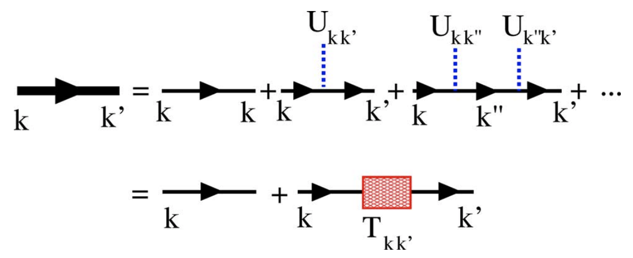

Figure 1. Feynman diagram for T-matrix treatment of the QPI process[1]

The multiple scattering process can also be understood in real space (Fig.2)

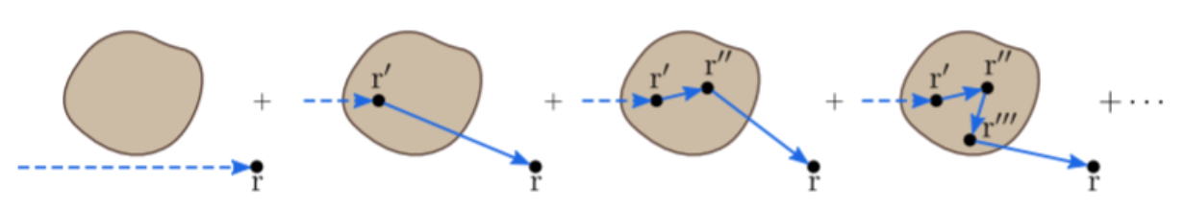

Figure 2. The multiple scattering process in real space[1]

Then the density of states (DOS) in ***q***-space is

$$N\left(q,E\right)= -\frac{1}{π} Im \sum_{k}{G\left(k,k+q,E\right)} \\ = -\frac{1}{π} Im \sum_{k}{G_{0}\left(k,E\right)} -\frac{1}{π} Im \sum_{k}{G_{0}\left(k,E\right)T\left(k,k+q,E\right)G_{0}\left(k+q,E\right)} \\ =N_{0}+δN\left(q,E\right)$$

, where $q=k^{'}-k$ is the scattering vector, and $N_{0}=-\frac{1}{π} Im \sum_{k}{G_{0}\left(k,E\right)}$ is the unperturbed background DOS of the crystal without any scatters. The perturbed DOS in the ***q***-space, that is, the QPI pattern in ***q***-space, is

$$\begin{aligned}δN\left(q,E\right)= -\frac{1}{π} Im \sum_{k}{G_{0}\left(k,E\right)T\left(k,k+q,E\right)G_{0}\left(k+q,E\right)}\#\left(3\right)\end{aligned}$$

Note that $N_{0}$ and $δN\left(q,E\right)$ defined here are physically measurable quantities. They are all real numbers. This is in contrast with if one defines a real $δN\left(r,E\right)$ (which is also experimentally measurable), its Fourier transform “ $δN\left(q,E\right)$” would have both real and imaginary parts, depending on if the defect is located at the center of the image.

If we assume a one band model and a perfectly localized **potential scatter** and thus scattering process is isotropic such that

$$U_{k,k^{''}}=U_{0}$$

according to Eq. 4 $T(k,k^{'},E)$ would only depend on energy

$$\begin{aligned}T\left(E\right)= U_{0}+ U_{0}\sum_{k}{G_{0}\left(k,E\right)T\left(E\right)}\#\left(4\right)\end{aligned}$$

Therefore, $T\left(E\right)$ can be solved in a closed form

$$\begin{aligned}T\left(E\right)={\left(1- U_{0}\sum_{k}{G_{0}\left(k,E\right)}\right)}^{-1}U_{0}\#\left(5\right)\end{aligned}$$

Let $G_{0}\left(r,E\right)$ be the inverse Fourier transform of $G_{0}\left(k,E\right)$

$$G_{0}\left(r,E\right)≡F^{-1}\left(G_{0}\left(k,E\right)\right)=\sum_{k}{G_{0}\left(k,E\right)e^{ik⋅r}}$$

Then, we realized the sum of bare Green’s function and the T-matrix can be simplified as

$$\sum_{k}{G_{0}\left(k,E\right)}={\left.F\left(G_{0}\left(k,E\right)\right)\right|}_{r=0}=G_{0}\left(0,E\right)$$

$$T\left(E\right)={\left(1- U_{0}G_{0}\left(0,E\right)\right)}^{-1}U_{0}$$

As the summation over the entire ***k***-space, we can replace the summation as –***k***.

$$δN\left(q,E\right)= -\frac{1}{π} Im \left[\sum_{k}{G_{0}\left(k,E\right)T\left(E\right)G_{0}\left(k+q,E\right)}\right] \\ = -\frac{1}{π} Im \left[\sum_{-k}{G_{0}\left(k,E\right)T\left(E\right)G_{0}\left(q-(-k),E\right)}\right]$$

Now we try to write the summation in $δN\left(q,E\right)$ as a convolution and apply the convolution theorem. To do so, let’s define ${\tilde{G}}_{0}\left(-k,E\right)≡G_{0}\left(k,E\right)$. Therefore,

$$δN\left(q,E\right)= -\frac{1}{π} Im \left[\sum_{-k}{{\tilde{G}}_{0}\left(-k,E\right)T\left(E\right)G_{0}\left(q-\left(-k\right),E\right)}\right]=-\frac{1}{π} Im \left[\sum_{k}{{\tilde{G}}_{0}\left(k,E\right)T\left(E\right)G_{0}\left(q-k,E\right)}\right]=-\frac{1}{π} Im \left[F\left\{F^{-1}\left[\sum_{k}{{\tilde{G}}_{0}\left(k,E\right)\left[T\left(E\right)G_{0}\left(q-k,E\right)\right]}\right]\right\}\right]=-\frac{1}{π} Im \left[F\left\{F^{-1}\left[{\tilde{G}}_{0}\left(k,E\right)\right]∙F^{-1}\left[T\left(E\right)G_{0}\left(k,E\right)\right]\right\}\right]$$

$$=-\frac{1}{π} Im \left\{F\{G_{0}\left(-r,E\right)∙[T\left(E\right)G_{0}\left(r,E\right)]\}\right\}$$

, where “ $∙$” denotes element-wise multiplication instead of matrix product. Here $G_{0}\left(-r,E\right)=F^{-1}\left(G_{0}\left(-k,E\right)\right)$ and $G_{0}\left(r,E\right)=F^{-1}\left(G_{0}\left(k,E\right)\right)$.

### 2.1.2 BQPI Simulation

For a superconductor, the dispersion relation becomes

$$\begin{aligned}E\left(k\right)= \sqrt{ϵ{\left(k\right)}^{2}+Δ{\left(k\right)}^{2}}\#\left(6\right)\end{aligned}$$

where $Δ(k)$ is the superconducting energy gap in ***k***-space and $ϵ(k)$ is the dispersion relation in the normal state. By reconstructing the constant energy contours in the ***k***-space from BQPI patterns, the structure of $Δ(k)$ can be revealed.

The **one-band** Bogoliubov de Gennes Hamiltonian under the spinor basis of $ψ^{†}=(c_{k↑ }^{†}, c_{-k↓})$ is[2]

then the bare Green's function is

$$\begin{aligned}G_{0}\left(k,E\right)={\left(\left(E+iδ\right)I-H_{BdG}\left(k\right)\right)}^{-1}\#\left(8\right)\end{aligned}$$

where *I* is a 2 by 2 identify matrix. If we assume a perfectly localized **potential scatter** (as opposed to magentci scatters) and thus scattering process is isotropic, the scattering potential is:

$$U_{k,k^{''}}=U=\left(\begin{matrix}U_{0} & 0 \\ 0 & -U_{0}\end{matrix}\right)$$

The T-matrix is

$$T\left(E\right)={\left(I- UG_{0}\left(0,E\right)\right)}^{-1}U$$

Therefore, the DOS in ***q***-space can be calculated as

$$\begin{aligned}δN\left(q,E\right)= -\frac{1}{π} Im{\left[\sum_{k}{G_{0}\left(k,E\right)T\left(E\right)G_{0}\left(k+q,E\right)}\right]}_{11} \\ =-\frac{1}{π} Im {\left\{F\{G_{0}\left(-r,E\right)∙[T\left(E\right)G_{0}\left(r,E\right)]\}\right\}}_{11}\#\left(9\right)\end{aligned}$$

Note, the position of $T\left(E\right)$ cannot be changed as in BQPI, $G_{0}$ and $T\left(E\right)$ are matrices. Without magnetic scattering, spin-up and spin-down states would be equal in number. Therefore, counting only the 11 component, which corresponds to only one spin species, is sufficient.

For a **two-band** system under the spinor basis of

$$ψ^{†}=(c_{1,k↑ }^{†}, c_{1, -k↓},c_{2,k↑ }^{†}, c_{2, -k↓})$$

the Bogoliubov de Gennes Hamiltonian $\sum_{k}{ψ^{†}\left(k\right)H_{BdG}\left(k\right)ψ\left(k\right)}$ can be written as

$$\begin{aligned}H_{BdG}\left(k\right)= \left(\begin{matrix}ϵ_{1}\left(k\right) & Δ_{1}\left(k\right) & ϵ_{12}\left(k\right) & 0 \\ Δ_{1^{*}}\left(k\right) & -ϵ_{1}\left(k\right) & 0 & -ϵ_{12}\left(k\right) \\ ϵ_{12}\left(k\right) & 0 & ϵ_{2}\left(k\right) & Δ_{2}\left(k\right) \\ 0 & {-ϵ}_{12}\left(k\right) & Δ_{2}^{*}\left(k\right) & -ϵ_{2}\left(k\right)\end{matrix}\right)\#\left(10\right)\end{aligned}$$

, where $ϵ_{i}\left(k\right)$ and $Δ_{i}\left(k\right)$ are the normal state dispersion and gap functions of the two bands; $ϵ_{12}\left(k\right)$ is a hybridization term of the two bands, which are often assumed to be zero for simplicity. The overall scattering potential is now a 4 by 4 matrix as well

$$U= \left(\begin{matrix}U_{intra} & 0 & U_{inter} & 0 \\ 0 & -U_{intra} & 0 & -U_{inter} \\ U_{inter} & 0 & U_{intra} & 0 \\ 0 & -U_{inter} & 0 & {-U}_{intra}\end{matrix}\right)$$

$$=\left( U_{intra}I + U_{inter}σ_{x}\right) ⨂ σ_{z}$$

The T-matrix is

$$T\left(E\right)={\left(I- UG_{0}\left(0,E\right)\right)}^{-1}U$$

and the change in the density of states is

$$\begin{aligned}δN\left(q,E\right)= -\frac{1}{π} Im\sum_{i=1 and 3}{{\left[\sum_{k}{G_{0}\left(k,E\right)T\left(E\right)G_{0}\left(k+q,E\right)}\right]}_{ii}} \\ =\sum_{i=1 and 3 }{-\frac{1}{π} Im {\left\{F\left[F^{-1}\left[G_{0}\left(-k,E\right)\right]∙\left\{T\left(E\right)F^{-1}\left[G_{0}\left(k,E\right)\right]\right\}\right]\right\}}_{ii}}\#\end{aligned}$$

## 2.2 The Joint Density of States (JDOS) Method

In section 2.1, T-matrix method is used for (B)QPI calculation. Alternatively, one may use the JDOS method[3]. Intuitively, JDOS postulates that $δN\left(q,E\right)$ is proportional to the density of pairs of states $(|\left.k'\left(E\right)\right\rangle ,\left|\left.k\left(E\right)\right\rangle \right)$, where $q=k^{'}-k$. The wavevectors that connect large regions of constant energy contours in the ***k***-space generate the most scattering, which is what JDOS captures. Such wavevectors are said to be nested, which is schematically demonstrated in Fig. 3.

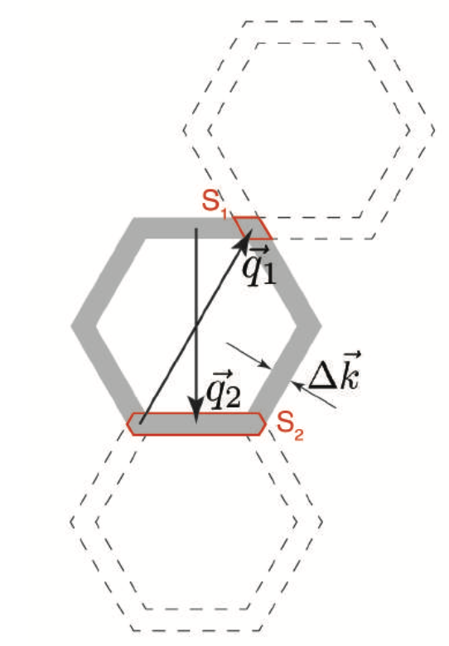

Figure 3. Geometrical construction illustrating nesting[4]

Using the retarded Green’s function, the spectral density can be calculated as

$$\begin{aligned}A_{0}\left(k,E\right)= -\frac{1}{π} Im\sum_{i}{{\left[G_{0}\left(k,E\right)\right]}_{ii}}\#\left(11\right)\end{aligned}$$

For a one-band model, i=1,2. Then, the BQPI pattern is calculated as the autocorrelation of the spectral density

$$\begin{aligned}δN\left(q,E\right) ≅ \int{A_{0}\left(k,E\right)A{}_{0}\left(k+q,E\right)dk}\#\left(12\right)\end{aligned}$$

# 3.The Implementation of BQPI Simulation in MATLAB

## 3.1 The T-matrix Method

### 3.1.1 One-band model (e.g., BSCCO)

**Define key parameters**

1. Number of points in k-space, that is, the number of points in the first Brillouin zone $(-\frac{π}{a}, \frac{π}{a})$, which is n_q in the code. Set the k-space unit to $\frac{1}{a}$ (a is the lattice parameter), then the k-space of first Brillouin zone is $k_{x}ϵ\left(-π,π\right)$, $k_{y}ϵ\left(-π,π\right)$, and it is divided into points according to the number of points we set. That is, we use the ‘linspace’ command to generate a coordinate vector, and then use the ‘meshgrid’ command to generate a matrix $k[k_{x},k_{y}]$ for subsequent calculations:

n_q = nq*;*

[kx,ky] = meshgrid(linspace(-pi,pi,n_q));

1. The energy range $(-E, E)$, which is E in the code with unit of eV.

E = e;

1. The number of energy layers, which is n_E in the code. The energy range $(-E, E)$ is divided into several points according to the number of points we set, and the ‘linspace’ command is used to generate the vector Epoints.

n_E = ne*;*

Epoints = linspace(-E,E,n_E);

1. Energy smearing $δ$ in Green’s function, which is d in the code with unit of eV.

d = d1;

1. The scattering potential, which is $U_{0}$ in the code with unit of eV.

U0= vintra;

(In the snapshot of script below, nq, e, ne, vintra, d1 are all parameters that need to be entered).

1. Use the scattering potential $U_{0}$ to generate the scattering potential matrix $U$, and define a 2 by 2 identity matrix :

$$\begin{aligned}U=\left(\begin{matrix}U_{0} & 0 \\ 0 & -U_{0}\end{matrix}\right)\#\left(13\right)\end{aligned}$$

U = [U0,0*;0,-U0];*

I = eye(2)*;*

1. Define the the normal state dispersion $ϵ(k)$ and energy gap $Δ(k)$, which are expressed as E_tb and D in the code respectively. Take $Bi_{2}Sr_{2}CaCu_{2}O_{8+δ}$ as an example, set the parameters as
2. n_q = 401*;*
3. E = 0.024*;*
4. n_E = 16*;*
5. U0 = 0.1*;*
6. E_tb = 0.1305 + -0.5951*(cos(kx)+cos(ky))/2+0.1636*cos(kx).*cos(ky)-0.0519*(cos(2*kx)+cos(2*ky))/2 -0.1117*(cos(2*kx).*cos(ky)+cos(kx).*cos(2*ky))/2 + 0.0510*cos(2*kx).*cos(2*ky)
7. D = 0.025/2*(cos(kx)-cos(ky))

The parameterization is from Wang and Lee (2003)[2], which is taken from Norman (1995)[5]. More parameterizations can be found in Table 3.1 of Rahul Sharma’s PhD thesis[6]. For $Bi_{2}Sr_{2}CaCu_{2}O_{8+δ}$, we can plot $ϵ(k)$ and $Δ\left(k\right)$ as shown in Fig. 4:

 

Figure 4. (a) the left is $ϵ(k)$ (b) the right is $Δ(k)$

**Calculate retarded Green’s function**

Compute Green's function for the unperturbed system according to Eq. 6

$$G_{0}\left(k,E\right)={\left(E+iδ-H_{0}\left(k\right)\right)}^{-1}$$

And $H_{0}\left(k\right)$ for one band material can be specifically written as

$$\begin{aligned}H_{0}\left(k\right)=\left(\begin{matrix}ϵ\left(k\right) & Δ\left(k\right) \\ Δ^{*}\left(k\right) & -ϵ\left(k\right)\end{matrix}\right)\#\left(14\right)\end{aligned}$$

so $G_{0}\left(k,E\right)$ is a $2×2$ matrix, $G_{0}\left(k,E\right)$ must be changed to

$$\begin{aligned}G_{0}\left(k,E\right)={\left(\left(E+iδ\right)I-H_{0}\left(k\right)\right)}^{-1}\#\left(15\right)\end{aligned}$$

where $I$ is the 2nd order identity matrix generated earlier.

Assuming

$$G_{0}(k,E)=\left(\begin{matrix}G_{11}(k,E) & G_{12}(k,E) \\ G_{21}(k,E) & G_{22}(k,E)\end{matrix}\right)$$

Import Fourier transform into our calculation

$$\begin{aligned}F^{-1}(G_{0}\left(k,E\right))=G_{0}\left(r,E\right)\#\left(16\right)\end{aligned}$$

We transform the k-space Green's function into a real-space Green's function through inverse Fourier transform:

$$G_{0}(r,E)=\left(\begin{matrix}G_{11r}(r,E) & G_{12r}(r,E) \\ G_{21r}(r,E) & G_{22r}(r,E)\end{matrix}\right)$$

Initialize each element of the matrices $G_{0}(k,E)$ and $G_{0}(r,E)$:

1. G11 = zeros(n_q,n_q,n_E)*;*
2. G12 = zeros(n_q,n_q,n_E)*;*
3. G21 = zeros(n_q,n_q,n_E)*;*
4. G22 = zeros(n_q,n_q,n_E)*;*
5. G11r = zeros(n_q,n_q,n_E)*;*
6. G12r = zeros(n_q,n_q,n_E)*;*
7. G21r = zeros(n_q,n_q,n_E)*;*
8. G22r= zeros(n_q,n_q,n_E)*;*

For each energy, use Eq. 14 and Eq. 15 to calculate $H_{0}\left(k\right)$, $G_{0}\left(k,E\right)$ corresponding to each $k(k_{x},k_{y})$, and write each element of $G_{0}\left(k,E\right)$ ( $2×2$ matrix) separately:

1. for k=1:n_E
2. for i=1:n_q
3. for j=1:n_q
4. H = [E_tb(i,j),D(i,j); conj(D(i,j)),-E_tb(i,j)];
5. G0 = I/((Epoints(k) + 1i*d)*I - H);
6. G11(i,j,k) = G0(1,1);
7. G12(i,j,k) = G0(1,2);
8. G21(i,j,k) = G0(2,1);
9. G22(i,j,k) = G0(2,2);
10. end
11. end
12. end

Calculate $G_{0}\left(r,E\right)$ using the inverse Fourier transform Eq. 16, i.e.

$$\left(\begin{matrix}G_{11r}(r,E) & G_{12r}(r,E) \\ G_{21r}(r,E) & G_{22r}(r,E)\end{matrix}\right)=\left(\begin{matrix}{F^{-1}(G}_{11}(k,E)) & {F^{-1}(G}_{12}(k,E)) \\ F^{-1}(G_{21}\left(k,E\right)) & {F^{-1}(G}_{22}(k,E))\end{matrix}\right)$$

Therefore, we can use the MATLAB command ‘ifft2’ for each energy layer, and then use the command ‘fftshift’ to shift the center, we can get

1. for k=1:n_E
2. G11r(:,:,k) = fftshift(ifft2(G11(:,:,k)))/(n_q*n_q);
3. G12r(:,:,k) = fftshift(ifft2(G12(:,:,k)))/(n_q*n_q);
4. G21r(:,:,k) = fftshift(ifft2(G21(:,:,k)))/(n_q*n_q);
5. G22r(:,:,k) = fftshift(ifft2(G22(:,:,k)))/(n_q*n_q);
6. end

**Calculate the Spectral Density Function**

Calculate the spectral density function at the same time, namely

$$A_{0}\left(k,E\right)= -\frac{1}{π} Im\sum_{i}{{\left[G_{0}\left(k,E\right)\right]}_{ii}} \\ =-\frac{1}{π}Im(G_{11}\left(k,E\right)+G_{22}(k,E))$$

1. Ak = -imag(G11+G22)/pi*;*

The calculated $A_{0}\left(k,E\right)$ is plotted in Fig. 5 below.



Figure 5. the spectral density function of BSCCO in each energy layer

**Calculate the T-Matrix**

As shown in section 2.1, the T matrix is

$$T\left(E\right)={\left(I- UG_{0}\left(0,E\right)\right)}^{-1}U$$

where

$$G_{0}\left(0,E\right)={\left.F^{-1}\left(G_{0}\left(k,E\right)\right)\right|}_{r=0}$$

It is easy to know that $T\left(E\right)$ is a $2×2$ matrix, which can be set

$$T(E)=\left(\begin{matrix}T_{11}(E) & T_{12}(E) \\ T_{21}(E) & T_{22}(E)\end{matrix}\right)$$

Initialize each element of $T\left(E\right)$

1. T11 = zeros(1,n_E)*;*
2. T12 = zeros(1,n_E)*;*
3. T21 = zeros(1,n_E)*;*
4. T22 = zeros(1,n_E)*;*

At the same time, find the index number corresponding to **r**=0

1. sumG_ind = (n_q+1)/2*;*

For each energy, use $G_{0}\left(0,E\right)$ to calculate the T-matrix:

1. for k=1:n_E
2. A = U;
3. B = [G11r(sumG_ind,sumG_ind,k),G12r(sumG_ind,sumG_ind,k);...
4. G21r(sumG_ind,sumG_ind,k),G22r(sumG_ind,sumG_ind,k)];
5. C = I - A*B;
6. T = 1/C*A;
7. T11(k) = T(1,1);
8. T12(k) = T(1,2);
9. T21(k) = T(2,1);
10. T22(k) = T(2,2);
11. end

**Calculate the BQPI pattern $δN\left(q,E\right)$**

Since

$$δN\left(q,E\right)=-\frac{1}{π} Im {\left\{F\{G_{0}\left(-r,E\right)∙[T\left(E\right)G_{0}\left(r,E\right)]\}\right\}}_{11}$$

In the algorithm, let

$$\begin{aligned}A_{r}=G_{0}\left(-r,E\right)∙[T\left(E\right)G_{0}\left(r,E\right)]\#\left(17\right)\end{aligned}$$

and

$$A_{r}=\left(\begin{matrix}A_{11r}(r,E) & A_{12r}(r,E) \\ A_{21r}(r,E) & A_{22r}(r,E)\end{matrix}\right)$$

then the calculation process is

1. A11r = zeros(n_q,n_q,n_E);
2. A22r = zeros(n_q,n_q,n_E);
3. for k=1:n_E
4. for i=1:n_q
5. for j=1:n_q
6. G1r = [G11r(i,j,k),G12r(i,j,k);...
7. G21r(i,j,k),G22r(i,j,k)];
8. G2r = [G11r(n_q-i+1,n_q-j+1,k),G12r(n_q-i+1,n_q-j+1,k);...
9. G21r(n_q-i+1,n_q-j+1,k),G22r(n_q-i+1,n_q-j+1,k)];
10. T = [T11(k),T12(k);...
11. T21(k),T22(k)];
12. A = G2r.*(T*G1r);
13. A11r(i,j,k) = A(1,1);
14. A22r(i,j,k) = A(2,2);
15. end
16. end
17. end

And $δN\left(q,E\right)$ can be calculated by

$$δN\left(q,E\right)=-\frac{1}{π} Im \left\{F\left[A_{11r}(r,E)\right]\right\}$$

1. dnq = zeros(n_q,n_q,n_E);
2. for k=1:n_E
3. dnq(:,:,k) = -imag(fftshift(fft2(ifftshift(A11r(:,:,k)))))/pi;
4. end

Since

$$δN\left(r,E\right)= F\left[δN\left(q,E\right)\right]$$

Therefore, $δN\left(r,E\right)$ can be calculated, which is expressed as dnr in the code

1. dnr = zeros(n_q,n_q,n_E);
2. for k=1:n_E
3. dnr(:,:,k) = fft2(dnq(:,:,k));
4. end

Using the data of $Bi_{2}Sr_{2}CaCu_{2}O_{8+δ}$, $δN\left(q,E\right)$ and $δN\left(r,E\right)$ can be obtained



Figure 6. $δN\left(q,E\right)$ of BSCCO

 Figure 7. $δN\left(r,E\right)$ of BSCCO

### 3.1.2 Two-band model (e.g., Sr2RuO4)

**Define key parameters**

For two bands simulation, the same parameters need to be set

1. n_q = nq;
2. E = e;
3. n_E = ne;
4. [kx,ky] = meshgrid(linspace(-pi,pi,n_q));
5. Epoints = linspace(-E,E,n_E);
6. I = eye(4);
7. d = d1;

The meaning of each parameter is the same as that of the one-band model, and the identity matrix $I$ represents a $4×4$ identity matrix. Since both intraband and interband scattering are invovled, the scattering potential $U$ can be set to $U_{intra}$ and $U_{inter}$ respectively (U_intra and U_inter in the code; unit is eV).

$$U= \left(\begin{matrix}U_{intra} & 0 & U_{inter} & 0 \\ 0 & -U_{intra} & 0 & -U_{inter} \\ U_{inter} & 0 & U_{intra} & 0 \\ 0 & -U_{inter} & 0 & {-U}_{intra}\end{matrix}\right)$$

$$=\left( U_{intra}I + U_{inter}σ_{x}\right) ⨂ σ_{z}$$

1. U_intra = uintra*;*
2. U_inter = uinter*;*
3. U = [U_intra,0,U_inter,0*;...*
4. 0,-U_intra,0,-U_inter*;...*
5. U_inter,0,U_intra,0*;...*
6. 0,-U_inter,0,-U_intra]*;*

After giving each parameter, introduce the energy band $ϵ_{1}\left(k\right),ϵ_{2}(k)$ and energy gap $Δ_{1}(k), Δ_{2}(k)$ (epsilon_1, epsilon_2, D1, D2 in code). For example, for Sr2RuO4 (using and $ϵ_{β}$ bands), they are:

1. n_q = 501;
2. E = 0.001;
3. n_E = 21;
4. U_intra = 1;
5. U_inter = 0.1;
6. d = 0.0015;
7. mu_0 = 1;
8. t_h = 0.1;
9. V_m = 0.1;
10. mu_z = 0.7;
11. t_z = 0.55;
12. t_z1 = 0.2;
13. t = 1;
15. epsilon_xz = - mu_0 - 2*t*cos(kx) - 2*t_h*cos(ky);
16. epsilon_yz = - mu_0 - 2*t*cos(ky) - 2*t_h*cos(kx);
17. V_hyb = - 2*V_m*sin(kx).*sin(ky);
18. epsilon_1 = 1/2*((epsilon_xz + epsilon_yz) ...
19. - sqrt((epsilon_xz - epsilon_yz).^2 + 4*V_hyb.^2));
20. epsilon_2 = 1/2*((epsilon_xz + epsilon_yz) ...
21. + sqrt((epsilon_xz - epsilon_yz).^2 + 4*V_hyb.^2));
23. D0_1 = 0.00035;
24. D0_2 = 0.00035;
25. D1 = D0_1*(cos(kx) - cos(ky));
26. D2 = D0_2*(cos(kx) - cos(ky));

The parameters are given by Firmo’s paper[7].

and for Sr2RuO4 are plotted below:

 

Figure 8. (a) the left is $Δ_{1}(k)$ (b) the right is $Δ_{2}(k)$

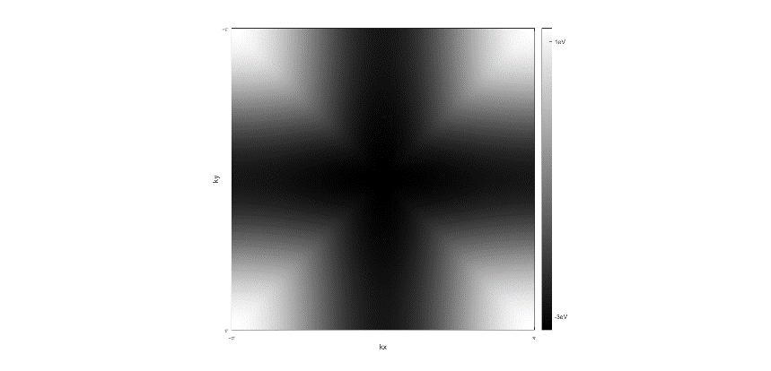 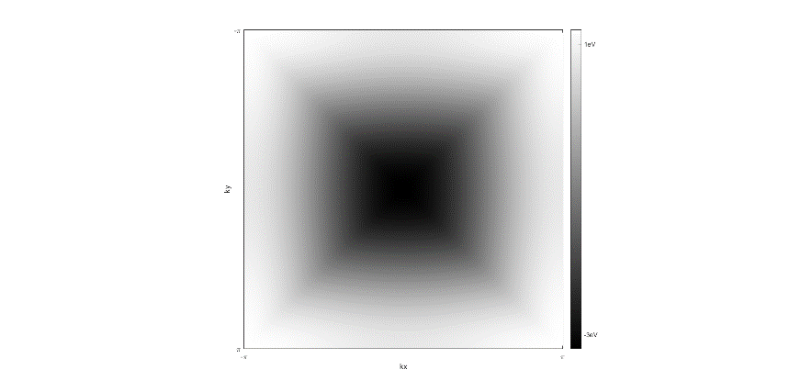

Figure 9. (a) the left is $ϵ_{1}(k)$ (b) the right is $ϵ_{2}(k)$

**Calculate retarded Green’s function**

The Bogoliubov de Gennes Hamiltonian of the two-band model without hybridization can be written as

$$\begin{aligned}H_{0}\left(k\right)= \left(\begin{matrix}ϵ_{1}\left(k\right) & Δ_{1}\left(k\right) & 0 & 0 \\ Δ_{1^{*}}\left(k\right) & -ϵ_{1}\left(k\right) & 0 & 0 \\ 0 & 0 & ϵ_{2}\left(k\right) & Δ_{2}\left(k\right) \\ 0 & 0 & Δ_{2}^{*}\left(k\right) & -ϵ_{2}\left(k\right)\end{matrix}\right)\#\left(18\right)\end{aligned}$$

so $G_{0}\left(k,E\right)$ is a $4×4$ matrix.

Assuming

$$G_{0}(k,E)=\left(\begin{matrix}G_{11}(k,E) & G_{12}(k,E) & G_{13}(k,E) & G_{14}(k,E) \\ G_{21}(k,E) & G_{22}(k,E) & G_{23}(k,E) & G_{24}(k,E) \\ G_{31}(k,E) & G_{32}(k,E) & G_{33}(k,E) & G_{34}(k,E) \\ G_{41}(k,E) & G_{42}(k,E) & G_{43}(k,E) & G_{44}(k,E)\end{matrix}\right)$$

We can also import convolution into our calculation according to Eq. 16, so we have

$$G_{0}(r,E)=\left(\begin{matrix}G_{11r}(r,E) & G_{12r}(r,E) & G_{13r}(r,E) & G_{14r}(r,E) \\ G_{21r}(r,E) & G_{22r}(r,E) & G_{23r}(r,E) & G_{24r}(r,E) \\ G_{31r}(r,E) & G_{32r}(r,E) & G_{33r}(r,E) & G_{34r}(r,E) \\ G_{41r}(r,E) & G_{42r}(r,E) & G_{43r}(r,E) & G_{44r}(r,E)\end{matrix}\right)$$

Initialize the matrix

1. G11 = zeros(n_q,n_q,n_E)*;*
2. G12 = zeros(n_q,n_q,n_E)*;*
3. G13 = zeros(n_q,n_q,n_E)*;*
4. G14 = zeros(n_q,n_q,n_E)*;*
5. G21 = zeros(n_q,n_q,n_E)*;*
6. G22 = zeros(n_q,n_q,n_E)*;*
7. G23 = zeros(n_q,n_q,n_E)*;*
8. G24 = zeros(n_q,n_q,n_E)*;*
9. G31 = zeros(n_q,n_q,n_E)*;*
10. G32 = zeros(n_q,n_q,n_E)*;*
11. G33 = zeros(n_q,n_q,n_E)*;*
12. G34 = zeros(n_q,n_q,n_E)*;*
13. G41 = zeros(n_q,n_q,n_E)*;*
14. G42 = zeros(n_q,n_q,n_E)*;*
15. G43 = zeros(n_q,n_q,n_E)*;*
16. G44 = zeros(n_q,n_q,n_E)*;*
17. G11r = zeros(n_q,n_q,n_E)*;*
18. G12r = zeros(n_q,n_q,n_E)*;*
19. G13r = zeros(n_q,n_q,n_E)*;*
20. G14r = zeros(n_q,n_q,n_E)*;*
21. G21r = zeros(n_q,n_q,n_E)*;*
22. G22r = zeros(n_q,n_q,n_E)*;*
23. G23r = zeros(n_q,n_q,n_E)*;*
24. G24r = zeros(n_q,n_q,n_E)*;*
25. G31r = zeros(n_q,n_q,n_E)*;*
26. G32r = zeros(n_q,n_q,n_E)*;*
27. G33r = zeros(n_q,n_q,n_E)*;*
28. G34r = zeros(n_q,n_q,n_E)*;*
29. G41r = zeros(n_q,n_q,n_E)*;*
30. G42r = zeros(n_q,n_q,n_E)*;*
31. G43r = zeros(n_q,n_q,n_E)*;*
32. G44r = zeros(n_q,n_q,n_E)*;*

Calculate $H_{0}\left(k\right)$ and $G_{0}\left(k,E\right)$ using Eq. 18 and Eq. 15 and write each element of $G_{0}\left(k,E\right)$ separately

1. for k=1:n_E
2. for i=1:n_q
3. for j=1:n_q
4. H = [epsilon_1(i,j),D1(i,j),0,0;...
5. conj(D1(i,j)),-epsilon_1(i,j),0,0;...
6. 0,0,epsilon_2(i,j),D2(i,j);...
7. 0,0,conj(D2(i,j)),-epsilon_2(i,j)];
8. G0 = I/((Epoints(k) + 1i*d)*I - H);
9. G11(i,j,k) = G0(1,1);
10. G12(i,j,k) = G0(1,2);
11. G13(i,j,k) = G0(1,3);
12. G14(i,j,k) = G0(1,4);
13. G21(i,j,k) = G0(2,1);
14. G22(i,j,k) = G0(2,2);
15. G23(i,j,k) = G0(2,3);
16. G24(i,j,k) = G0(2,4);
17. G31(i,j,k) = G0(3,1);
18. G32(i,j,k) = G0(3,2);
19. G33(i,j,k) = G0(3,3);
20. G34(i,j,k) = G0(3,4);
21. G41(i,j,k) = G0(4,1);
22. G42(i,j,k) = G0(4,2);
23. G43(i,j,k) = G0(4,3);
24. G44(i,j,k) = G0(4,4);
25. end
26. end
27. end

Using inverse Fourier transform Eq. 16, $G_{0}\left(r,E\right)$ can be calculated

1. for k=1:n_E
2. G11r(:,:,k) = fftshift(ifft2(G11(:,:,k)))/(n_q*n_q);
3. G12r(:,:,k) = fftshift(ifft2(G12(:,:,k)))/(n_q*n_q);
4. G13r(:,:,k) = fftshift(ifft2(G13(:,:,k)))/(n_q*n_q);
5. G14r(:,:,k) = fftshift(ifft2(G14(:,:,k)))/(n_q*n_q);
6. G21r(:,:,k) = fftshift(ifft2(G21(:,:,k)))/(n_q*n_q);
7. G22r(:,:,k) = fftshift(ifft2(G22(:,:,k)))/(n_q*n_q);
8. G23r(:,:,k) = fftshift(ifft2(G23(:,:,k)))/(n_q*n_q);
9. G24r(:,:,k) = fftshift(ifft2(G24(:,:,k)))/(n_q*n_q);
10. G31r(:,:,k) = fftshift(ifft2(G31(:,:,k)))/(n_q*n_q);
11. G32r(:,:,k) = fftshift(ifft2(G32(:,:,k)))/(n_q*n_q);
12. G33r(:,:,k) = fftshift(ifft2(G33(:,:,k)))/(n_q*n_q);
13. G34r(:,:,k) = fftshift(ifft2(G34(:,:,k)))/(n_q*n_q);
14. G41r(:,:,k) = fftshift(ifft2(G41(:,:,k)))/(n_q*n_q);
15. G42r(:,:,k) = fftshift(ifft2(G42(:,:,k)))/(n_q*n_q);
16. G43r(:,:,k) = fftshift(ifft2(G43(:,:,k)))/(n_q*n_q);
17. G44r(:,:,k) = fftshift(ifft2(G44(:,:,k)))/(n_q*n_q);
18. end

**Calculate the Spectral Density Function**

For a two-band model, the spectral density function is

$$A_{0}\left(k,E\right)=-\frac{1}{π}Im(G_{11}\left(k,E\right)+G_{22}\left(k,E\right)+G_{33}\left(k,E\right)+G_{44}(k,E))$$

1. Ak = -imag(G11+G22+G33+G44)/pi*;*

Using the parameters of $Sr_{2}RuO_{4}$, the calculation results are as follows

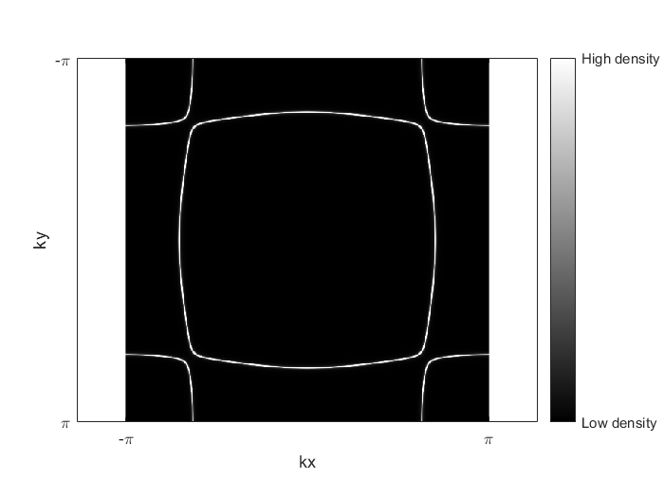

Figure 10. The spectral density function $A_{0}\left(k,0.001 eV\right)$ ( $A_{0}\left(k,E\right)$ is basically energy-independent)

**Calculate the T-Matrix**

Since T(E) becomes a $4×4$ matrix, it can be set as

$$T(E)=\left(\begin{matrix}T_{11}(E) & T_{12}(E) & T_{13}(E) & T_{14}(E) \\ T_{21}(E) & T_{22}(E) & T_{23}(E) & T_{24}(E) \\ T_{31}(E) & T_{32}(E) & T_{33}(E) & T_{34}(E) \\ T_{41}(E) & T_{42}(E) & T_{43}(E) & T_{44}(E)\end{matrix}\right)$$

Initialize each element of $T\left(E\right)$

1. T11 = zeros(1,n_E)*;*
2. T12 = zeros(1,n_E)*;*
3. T13 = zeros(1,n_E)*;*
4. T14 = zeros(1,n_E)*;*
5. T21 = zeros(1,n_E)*;*
6. T22 = zeros(1,n_E)*;*
7. T23 = zeros(1,n_E)*;*
8. T24 = zeros(1,n_E)*;*
9. T31 = zeros(1,n_E)*;*
10. T32 = zeros(1,n_E)*;*
11. T33 = zeros(1,n_E)*;*
12. T34 = zeros(1,n_E)*;*
13. T41 = zeros(1,n_E)*;*
14. T42 = zeros(1,n_E)*;*
15. T43 = zeros(1,n_E)*;*
16. T44 = zeros(1,n_E)*;*

Similar to one band simulation, find the index number corresponding to **r**=0

1. sumG_ind = (n_q+1)/2*;*

For each energy layer, calculate $T(E)$

1. for k=1:n_E
2. A = U;
3. B = [G11r(sumG_ind,sumG_ind,k),G12r(sumG_ind,sumG_ind,k),...
4. G13r(sumG_ind,sumG_ind,k),G14r(sumG_ind,sumG_ind,k);...
5. G21r(sumG_ind,sumG_ind,k),G22r(sumG_ind,sumG_ind,k),...
6. G23r(sumG_ind,sumG_ind,k),G24r(sumG_ind,sumG_ind,k);...
7. G31r(sumG_ind,sumG_ind,k),G32r(sumG_ind,sumG_ind,k),...
8. G33r(sumG_ind,sumG_ind,k),G34r(sumG_ind,sumG_ind,k);...
9. G41r(sumG_ind,sumG_ind,k),G42r(sumG_ind,sumG_ind,k),...
10. G43r(sumG_ind,sumG_ind,k),G44r(sumG_ind,sumG_ind,k)];
11. C = I - A*B;
12. T = 1/C*A;
13. T11(k) = T(1,1);
14. T12(k) = T(1,2);
15. T13(k) = T(1,3);
16. T14(k) = T(1,4);
17. T21(k) = T(2,1);
18. T22(k) = T(2,2);
19. T23(k) = T(2,3);
20. T24(k) = T(2,4);
21. T31(k) = T(3,1);
22. T32(k) = T(3,2);
23. T33(k) = T(3,3);
24. T34(k) = T(3,4);
25. T41(k) = T(4,1);
26. T42(k) = T(4,2);
27. T43(k) = T(4,3);
28. T44(k) = T(4,4);
29. end

**Calculate the BQPI pattern $δN\left(q,E\right)$**

Similarly, write $A_{r}$ as

$$A_{r}=\left(\begin{matrix}A_{11r}(r,E) & A_{12r}(r,E) & A_{13r}(r,E) & A_{14r}(r,E) \\ A_{21r}(r,E) & A_{22r}(r,E) & A_{23r}(r,E) & A_{24r}(r,E) \\ A_{31r}(r,E) & A_{32r}(r,E) & A_{33r}(r,E) & A_{34r}(r,E) \\ A_{41r}(r,E) & A_{42r}(r,E) & A_{43r}(r,E) & A_{44r}(r,E)\end{matrix}\right)$$

The initialization matrix and the calculation process of $A_{r}$ are as follows

1. for k=1:n_E
2. for i=1:n_q
3. for j=1:n_q
4. G1 = [G11r(i,j,k),G12r(i,j,k),G13r(i,j,k),G14r(i,j,k);...
5. G21r(i,j,k),G22r(i,j,k),G23r(i,j,k),G24r(i,j,k);...
6. G31r(i,j,k),G32r(i,j,k),G33r(i,j,k),G34r(i,j,k);...
7. G41r(i,j,k),G42r(i,j,k),G43r(i,j,k),G44r(i,j,k)];
8. G2 = [G11r(n_q-i+1,n_q-j+1,k),G12r(n_q-i+1,n_q-j+1,k),...
9. G13r(n_q-i+1,n_q-j+1,k),G14r(n_q-i+1,n_q-j+1,k);...
10. G21r(n_q-i+1,n_q-j+1,k),G22r(n_q-i+1,n_q-j+1,k),...
11. G23r(n_q-i+1,n_q-j+1,k),G24r(n_q-i+1,n_q-j+1,k);...
12. G31r(n_q-i+1,n_q-j+1,k),G32r(n_q-i+1,n_q-j+1,k),...
13. G33r(n_q-i+1,n_q-j+1,k),G34r(n_q-i+1,n_q-j+1,k);...
14. G41r(n_q-i+1,n_q-j+1,k),G42r(n_q-i+1,n_q-j+1,k),...
15. G43r(n_q-i+1,n_q-j+1,k),G44r(n_q-i+1,n_q-j+1,k)];
16. T = [T11(k),T12(k),T13(k),T14(k);...
17. T21(k),T22(k),T23(k),T24(k);...
18. T31(k),T32(k),T33(k),T34(k);...
19. T41(k),T42(k),T43(k),T44(k)];
20. A = G2.*(T*G1);
21. A11r(i,j,k) = A(1,1);
22. A22r(i,j,k) = A(2,2);
23. A33r(i,j,k) = A(3,3);
24. A44r(i,j,k) = A(4,4);
25. end
26. end

Then calculate $δN(q, E)$ as

1. dnq = zeros(n_q,n_q,n_E);
2. for k=1:n_E
3. dnq(:,:,k) = -imag(fftshift(fft2(ifftshift(A11r(:,:,k)+A33r(:,:,k)))))/pi;
4. end

and calculate $δN(r,E)$

1. dnr = zeros(n_q,n_q,n_E);
2. for k=1:n_E
3. dnr(:,:,k) = fft2(dnq(:,:,k));
4. end

For $Sr_{2}RuO_{4}$, the calculation result is

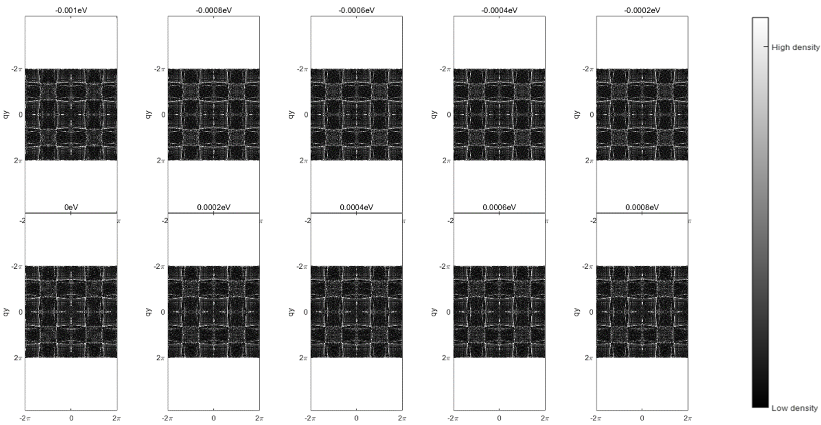

Figure 11. $δN\left(q,E\right)$ in $Sr_{2}RuO_{4}$

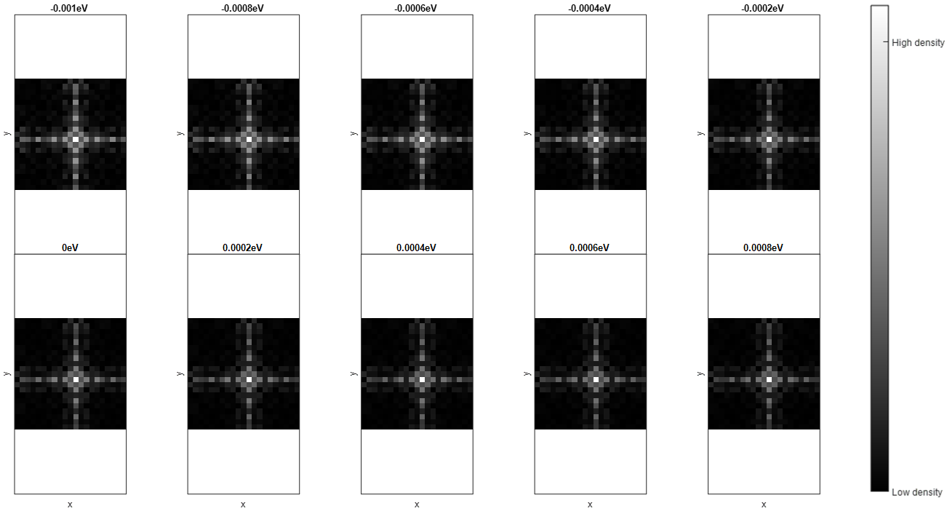

Figure 12. $δN\left(r,E\right)$ in $Sr_{2}RuO_{4}$

## 3.2 JDOS Method

### 3.2.1 One-band model (e.g., BSCCO)

For the Joint-DOS method, $δN\left(q,E\right)$ is

$$δN\left(q,E\right) ≅ \int{A_{0}\left(k,E\right)A{}_{0}(k+q,E)dk}$$

Considering that the integration is performed in the first Brillouin zone, if the $k+q$ vector exceeds the range of the first Brillouin zone, it must be converted back to the first Brillouin zone for calculation by subtracting $\frac{2Nπ}{a}$, where *N* is an integer. The specific process is as follows

1. ii = i + m;
2. jj = j + l;
3. if i + m > n_q
4. ii = i + m - n_q ;
5. end
6. if j + l > n_q
7. jj = j + l - n_q ;
8. end
9. if i + m < 1
10. ii = i + m + n_q ;
11. end
12. if j + l < 1
13. jj = j + l + n_q ;
14. end

After the above considerations, the specific $δN\left(q,E\right)$ integration process can be expressed by summation

1. dnq = zeros(n_q,n_q,n_E);
2. for k=1:n_E
3. for m=1:n_q
4. for l=1:n_q
5. sum1 = 0;
6. for i=1:n_q
7. for j=1:n_q
8. ii = i + m;
9. jj = j + l;
10. if i + m > n_q
11. ii = i + m - n_q ;
12. end
13. if j + l > n_q
14. jj = j + l - n_q ;
15. end
16. if i + m < 1
17. ii = i + m + n_q ;
18. end
19. if j + l < 1
20. jj = j + l + n_q ;
21. end
22. sum1 = sum1 + Ak(i,j,k)*Ak(ii,jj,k);
23. end
24. end
25. dnq(m,l,k) = sum1;
26. end
27. end
28. end

The calculation result of $Bi_{2}Sr_{2}CaCu_{2}O_{8+δ}$ is shown in Fig 13.



Figure 13. $δN\left(q,E\right)$ in BSCCO calculated by J-DOS (with n_q=201)

### 3.2.2 Two-band model (e.g., Sr2RuO4)

The simulation is the same to that of one-band model:

1. dnq = zeros(n_q,n_q,n_E);
2. for k=1:n_E
3. for m=1:n_q
4. for l=1:n_q
5. sum1 = 0;
6. for i=1:n_q
7. for j=1:n_q
8. ii = i + m;
9. jj = j + l;
10. if i + m > n_q
11. ii = i + m - n_q ;
12. end
13. if j + l > n_q
14. jj = j + l - n_q ;
15. end
16. if i + m < 1
17. ii = i + m + n_q ;
18. end
19. if j + l < 1
20. jj = j + l + n_q ;
21. end
22. sum1 = sum1 + Ak(i,j,k)*Ak(ii,jj,k);
23. end
24. end
25. dnq(m,l,k) = sum1;
26. end
27. end
28. end
29. end

For Sr2RuO4, the calculated result is

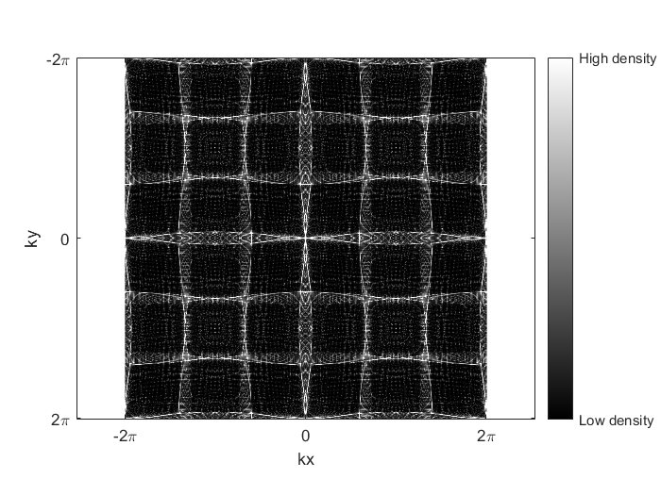

Figure 14. in Sr2RuO4calculated by J-DOS (with n_q=401)

# 4.Step-by-Step Guide of Software

All the code and this document can be downloaded in this link:

<https://github.com/zyw2362382/BQPI_APP>

and this is the screen snapshot of the MATLAB guide.

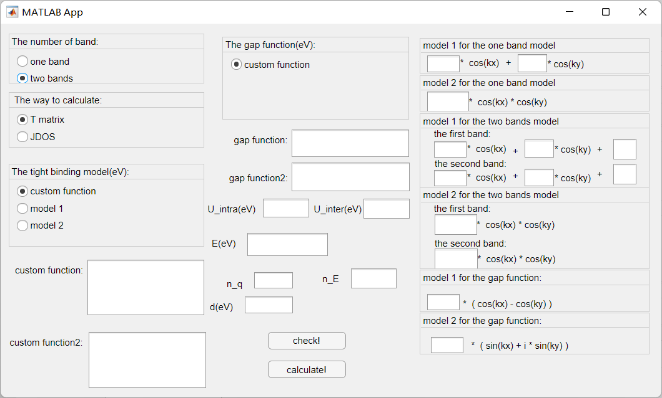

Figure 15. the screen snapshot of the MATLAB guide

This screen can be opened by clicking the button ‘Run’ in the MATLAB file.

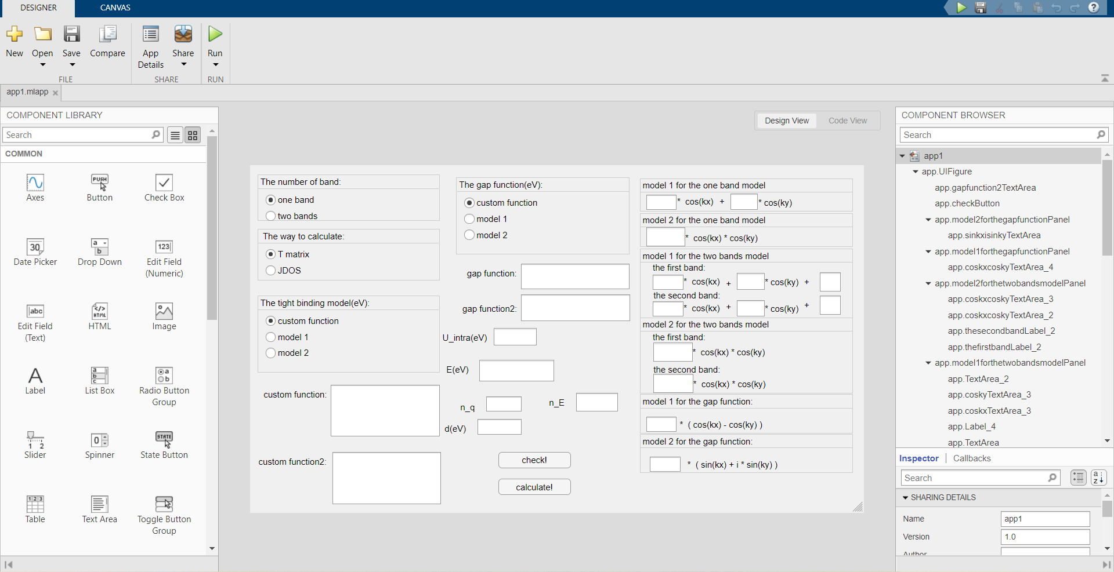

Figure 16. the screen snapshot of the MATLAB guide file

First, select the number of energy bands. This app can support the calculation of single energy band and two energy bands. Then choose to use T matrix or JDOS method for calculation.

Next, choose the model for energy band function and energy gap function. If you choose 'custom function', you need to fill in the blank in the corresponding position.

ATTENTION: the input function of ‘custom function’ needs to conform to the MATLAB function writing format. Take $Bi_{2}Sr_{2}CaCu_{2}O_{8+δ}$ as an example. This is a one band material. The energy band function and gap function are

$$ϵ\left(k\right)=0.1305-\frac{0.5951\left(\cos\left(k_{x}\right)+\cos\left(k_{y}\right)\right)}{2}+0.1636\cos\left(k_{x}\right)\cos\left(k_{y}\right)-\frac{0.0519\left(\cos\left(2k_{x}\right)+\cos\left(2k_{y}\right)\right)}{2}-\frac{0.1117\left(\cos\left(2k_{x}\right)cos\left(k_{y}\right)+\cos\left(2k_{y}\right)\cos\left(k_{x}\right)\right)}{2}+0.0510 cos⁡(2k_{x})cos⁡(2k_{y}) \\ Δ\left(k\right)=\frac{0.025\left(\cos\left(k_{x}\right)-\cos\left(k_{y}\right)\right)}{2}$$

The corresponding MATLAB writing is

$ϵ\left(k\right)=$ 0.1305 -0.5951*(cos(kx)+cos(ky))/2+0.1636*cos(kx).*cos(ky)-0.0519*(cos(2*kx)+cos(2*ky))/2 -0.1117*(cos(2*kx).*cos(ky)+cos(kx).*cos(2*ky))/2 + 0.0510*cos(2*kx).*cos(2*ky)

If you choose ‘model 1’ or ‘model 2’, you can fill the parameters to the corresponding positions.

Input other parameters required for the calculation.

1. ‘U_intra(eV)’ is the scattering potential for one band and the intraband scattering potential for two bands model. (the unit is eV) (magnitude is about 1eV)
2. ‘U_inter(eV)’ is the interband scattering potential for two bands model (not need to fill for one band). (the unit is eV) (magnitude is about 1eV)
3. ‘E(eV)’ is the maximum energy value measured. (the unit is eV) (magnitude is about 0.001-0.01eV)
4. ‘n_q’ is number of points in k-space. (‘n_q’ need to be odd for center to lie on a pixel) (301-501 maybe the optimal)
5. ‘n_E’ is the number of energies measured. (10-20 maybe the optimal)
6. ‘d(eV)’ is energy smearing. (the unit is eV) (magnitude is about 0.001-0.002eV)

Then click ‘check!’ button after confirming that it is correct. The calculated normal state dispersion, energy gap, and spectral density function will be displayed.

Finally, click ‘calculate!’ button. The spectral density function and the BQPI pattern corresponding to each energy will be displayed. At the same time, the current calculation process can be viewed in the main interface of MATLAB.

# 5.Reference

1. Balatsky, Alexander V., Ilya Vekhter, and Jian-Xin Zhu. "Impurity-induced states in conventional and unconventional superconductors." Reviews of Modern Physics 78.2 (2006): 373.
2. Wang, Qiang-Hua, and Dung-Hai Lee. "Quasiparticle scattering interference in high-temperature superconductors." Physical Review B 67.2 (2003): 020511.
3. Kostin, Andrey. STM Imaging of Strong Orbital-selective Correlations in FeSe. Diss. Cornell University, 2018.
4. Simon, Laurent, François Vonau, and Dominique Aubel. "A phenomenological approach of joint density of states for the determination of band structure in the case of a semi-metal studied by FT-STS." Journal of Physics: Condensed Matter 19.35 (2007): 355009.
5. Norman, M. R., et al. "Phenomenological models for the gap anisotropy of Bi 2 Sr 2 CaCu 2 O 8 as measured by angle-resolved photoemission spectroscopy." Physical Review B 52.1 (1995): 615.
6. Sharma, Rahul. Advanced Quasiparticle Interference Imaging for Complex Superconductors. Cornell University, 2020.
7. Firmo, I. A., et al. "Evidence from tunneling spectroscopy for a quasi-one-dimensional origin of superconductivity in Sr 2 RuO 4." Physical Review B 88.13 (2013): 134521.